**MULTILINGUAL GRAPH EXTRACTOR FOR DETECTION OF FRAUD IN DIGITAL PRODUCT FEEDBACK SYSTEMS**

*1A.Rakesh , 2R.Praveen ,3 B. Akhil, 4Mr.G.PanduKrishna*

# *1,2,3bachelor Degree, Cse,* *Jayamukhi Institute Of Technological Sciences Narsampet, Warangal.*

*4Mr. G.Pandu krishna, Assistant Professor, bachelor Degree, Cse, Jayamukhi Institute Of Technological Sciences Narsampet, Warangal.*

**ABSTRACT**

T Users are permitted to write reviews of the goods or services they have purchased using online review platforms. However, bogus evaluations published by dishonest persons frequently deceive customers and bring

losses for businesses. The majority of traditional fraud detection algorithms employ rule-based techniques, which are inadequate for complex user interactions and graph-structured data. Graph-based approaches have been suggested in recent years to deal with this scenario, although few earlier publications have noted the behaviour and varied character of the camouflage fraudster. These two issues have either not been solved by existing solutions or have only been partially addressed, which leads to subpar performance.

As an alternative, we provide a novel model called the Fraud Aware Heterogeneous Graph Transformer (FAHGT) to tackle consistency and camouflage issues together. To manage heterogeneous graph data, FAHGT uses a type-aware feature mapping mechanism. It then applies a variety of relation scoring techniques to reduce inconsistency and find concealment. The features of the neighbours are then combined to provide an informative depiction. Experimental findings on various data sets from real life show that FAHGT outperforms the cutting-edge baselines.

**INTRODUCTION**

Humans now have access to e-commerce, social networking, and entertainment platforms thanks to internet services, which not only make it easier to trade information but also provide scammers more opportunities. Fraudsters pose as regular users to post spam [1] or gather user privacy, jeopardising the interests of platforms and users alike. Additionally, there are several relationships connecting different Internet businesses.

These challenging heterogeneous graph data cannot be handled successfully by conventional machine learning methods. The current strategy is to describe the data as a heterogeneous information network in order to identify common traits and organisational structures among fraudsters. Graph neural networks (GNNs) have previously been used in fraud detection fields such as product evaluation [2]-[5], mobile application distribution [6], cyber crime identification [7], and financial services [8], thanks to their efficacy in learning the graph representation. How

The majority of GNN-based solutions now in use only employ homogeneous GNNs, omitting the underlying heterogeneous structure of the graph and masking node behaviours. With several solutions being presented, this subject has received a lot of attention [4], [5], and [10]. Three consistency issues with fraud detection were identified by GraphConsis [4], and CAREGNN [5] also offered two camouflage behaviours. The following might serve as a summary of these issues:

• Disguise: Earlier research demonstrated that members of the crowd could alter their behaviour to allay their suspicions by connecting to benign entities, such as highly reputable users, disguising fraudulent URLs with special characters [3], [6], or generating domain-independent fake reviews via generative language model [11].

• Inconsistency: By rating a similar product, such as food or films, two individuals with different preferences may get connected. GNNs virtually ever use direct aggregation.

recognise the distinct semantic user pattern. Additionally, if two individuals share an action, they should be more likely to be suspicious of one another because fraudulent people frequently publish several bogus reviews in a short amount of time.

Numerous solutions to the two issues mentioned above have been suggested. By calculating the similarity score between node embeddings, which cannot differentiate between nodes of different kinds, GraphConsis solves the consistency issue. By using a relational aware aggregator and a neighbour selection based on reinforcement learning, CAREGNN improves GNN-based fraud detectors against disguised fraudsters. The heterogeneous graph still has an adverse effect on its performance.

We introduce the Fraud Aware Heterogeneous Graph Transformer (FAHGT) in this research. To address the inconsistency problem, we suggest heterogeneous mutual attention, and to address the camouflage issue, we create a label-aware neighbour selection. The "score head mechanism" implements both methods uniformly. On various real-world datasets, we show the efficacy and efficiency of FAHGT. According to experimental findings, FAHGT can greatly outperform both modern GNNs and GNN-based fraud detectors in terms of KS and AUC.

The benefits of FAHGT are best summed up as follows:

• Heterogeneity: FAHGT can handle heterogeneous networks with many relations and nodes without having to manually create the meta-path.

• Adaptability: Given a noise graph made from real-world data, FAHGT carefully chooses neighbours. The chosen neighbours are either dangerous for fraud detection or informative for feature aggregation.

Efficiency: Through a parallelizable multi-head technique in relation scoring and feature aggregation, FAHGT allows for a low computing complexity.

• Flexibility: FAHGT introduces a modular relation scoring system, which injects expertise in the domain. The score of a connection between two nodes is limited by domain knowledge in addition to direct feature interaction.

**RELATED WORK**

BRAIN NETWORKS ON GRAPHS

A CNN generalisation to graphs is the Graph Neural Network [12]. The Fourier transformation in signal processing served as the foundation for the first graph convolution concept in the spectral domain [13]. Then, it is suggested to use approximation to increase efficiency utilising ChebNet [14] and GCN [15].

In order to calculate the root's hidden representation for GNNs in the spatial domain, GraphSAGE [16] selects a tree that is rooted at each node and hierarchically aggregates hidden node representations from the bottom to the top.

In addition, GAT [17] suggests using the masked selfattention mechanism to compute the relative significance of neighbouring nodes in order to learn in the spatial domain. These techniques are all intended for homogenous graphs. They cannot be used in place of

a graph that is heterogeneous and contains several kinds of items and interactions.

Numerous heterogeneous GNN-based techniques have been developed in recent years. Based on manually created meta-paths, HAN [18], HAHE [19], and DeepHGNN [20] divide a heterogeneous graph into numerous homogeneous graphs, apply GNN independently to each graph, then aggregate the result representations through attention method. Meta-paths are built by GraphInception [21] connecting nodes of the same object type.

HetGNN [22] uses a random walk approach to sample a fixed number of neighbours initially. For intra-type and inter-type formation, it then uses a hierarchical aggregation approach. Heterogeneous graphs are included in the transformer design of HGT [23]. They execute aggregation in accordance with the attention scores they directly generate for each target node's neighbours without taking domain knowledge into account.

**EXISTING SYSTEM:**

ChebNet and GCN are proposed to improve efficiency by using approximation. For GNNs on spatial domain, GraphSAGE samples a tree rooted at each node and computes the root’s hidden representation by hierarchically aggregating hidden node representations from the bottom to top. GAT further proposes to learn in the spatial domain by computing different importance of neighbor nodes via the masked self attention mechanism. All these methods are designed for homogeneous graphs. They cannot be directly applied to a heterogeneous graph with multiple types of entities and relations.

In recent years, lots of heterogeneous GNN based methods have been developed. HAN , HAHE , and Deep- HGNN transforms a heterogeneous graph into several homogeneous graphs based on handcrafted meta-paths, applies GNN separately on each graph, and aggregates the output representations by attention mechanism. GraphInception constructs meta-paths between nodes with the same object type. HetGNN first samples a fixed number of neighbors via random walk strategy. Then it applies a hierarchical aggregation mechanism for intratype and intertype aggregation. HGT extends transformer architecture to heterogeneous graphs. They directly calculate attention scores for all the neighbors of a target node and perform aggregation accordingly without considering domain knowledge.

For relation-aware graph fraud detectors, their main solution is to build multiple homogeneous graphs based on edge type information of the original graph then perform type independent node level aggregation and graph level concatenation. GEM learns weighting parameters for different homogeneous subgraph. Player2Vec and Semi GNN both adopt attention mechanism in feature aggregation and Semi GNN further leverages a structure loss to guarantee the node embeddings homophily. Some works directly aggregate heterogeneous information in the graph. For instance, under a user-review-item heterogeneous graph, GAS learns a unique set of aggregators for different node types and updates the embeddings of each node type iteratively

**PROPOSED SYSTEM:**

GraphConsis addresses the inconsistency problem by computing the similarity score between node embeddings, which cannot distinguish nodes with different types. CAREGNN enhances GNN-based fraud detectors against camouflaged fraudsters by reinforcement learning based neighbor selector and relation aware aggregator. Its performance still suffers from the heterogeneous graph.

In this paper, the system introduces the Fraud Aware Heterogeneous Graph Transformer(FAHGT), where we propose heterogeneous mutual attention to address the inconsistency problem and design a label-aware neighbor selector to solve the camouflage problem. Both are implemented in a unified manner called the “score head mechanism”. We demonstrate the effectiveness and efficiency of FAHGT on many real world datasets. Experimental results suggest that FAHGT can significantly improve KS and AUC over state-of-the-art GNNs as well as GNN-based fraud detectors.

**RESULT:**

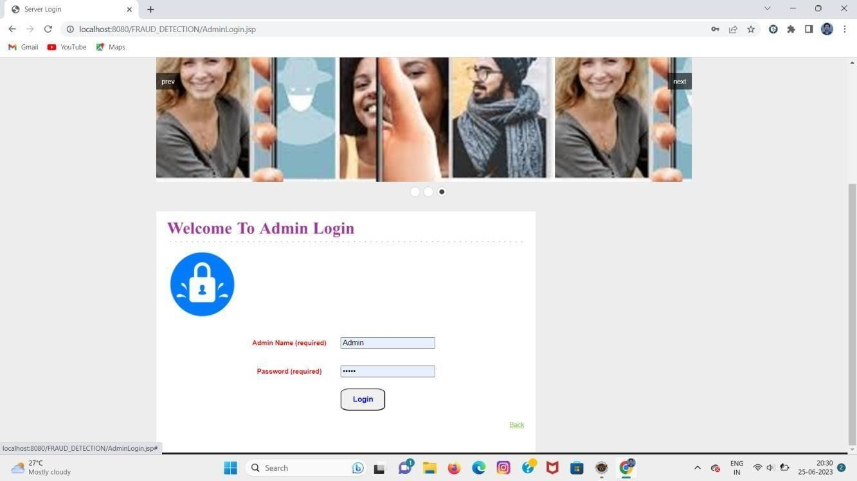

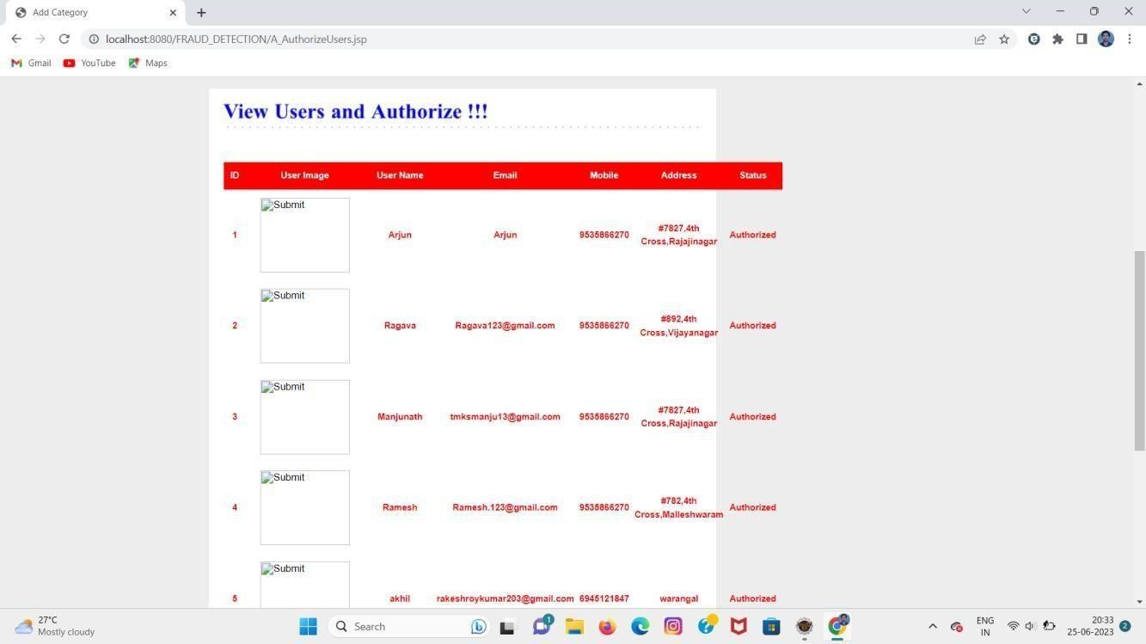

**CONCLUSION**

In this study, we present FAHGT, a novel heterogeneous graph neural network for online review systems' fraud user identification. We use heterogeneous mutual attention for automated meta path construction to manage inconsistent features. We provide label aware scoring to filter out loud neighbours in order to discover camouflage behaviours. The term "score" refers to the unified combination of two brain modules.

Both participate in the computation of edge weight in the final feature aggregation through the "head mechanism." The good impact of FAHGT on fraud detection has been validated by experiment results using real-world company datasets. The stability and effectiveness of our model are further demonstrated by the visual analysis and hyper-parameter sensitivity. In conclusion, FAHGT may eliminate consistency issues and detect camouflage, resulting in modern performance in the majority of situations. We intend to expand our model's capabilities in handling data from dynamic graphs and include fraud detection into other domains, such as strong product recommendations in e-commerce or loan default forecasting in financial services.

**REFERENCES**

[1] V. S. Tseng, J. Ying, C. Huang, Y. Kao, and K. Chen, “Fraudetector: A graph-mining-based framework for fraudulent phone call detection,” in Proceedings of the 21th ACM SIGKDD International Conference on Knowledge Discovery and Data Mining, Sydney, NSW, Australia, August 10-13, 2015, L. Cao, C. Zhang, T. Joachims, G. I. Webb, D. D. Margineantu, and G. Williams, Eds. ACM, 2015, pp. 2157–2166. [Online]. Available: https://doi.org/10.1145/2783258.2788623 [2] J. Wang, R. Wen, and C. Wu, “Fdgars: Fraudster detection via graph convolutional networks in online app review system,” in WWW Workshops, 2019. [3] A. Li, Z. Qin, R. Liu, Y. Yang, and D. Li, “Spam review detection with graph convolutional networks,” in CIKM, 2019. [4] Z. Liu, Y. Dou, P. S. Yu, Y. Deng, and H. Peng, “Alleviating the inconsistency problem of applying graph neural network to fraud detection,” in SIGIR, 2020. [5] Y. Dou, Z. Liu, L. Sun, Y. Deng, H. Peng, and P. S. Yu, “Enhancing graph neural network-based fraud detectors against camouflaged fraudsters,” in CIKM, 2020.[6] R. Wen, J. Wang, C. Wu, and J. Xiong, “Asa: Adversary situation awareness via heterogeneous graph convolutional networks,” in WWW Workshops, 2020. [7] Y. Zhang, Y. Fan, Y. Ye, L. Zhao, and C. Shi, “Key player identification in underground forums over attributed heterogeneous information network embedding framework,” in CIKM, 2019. [8] D. Wang, J. Lin, P. Cui, Q. Jia, Z. Wang, Y. Fang, Q. Yu, and J. Zhou, “A semi-supervised graph attentive network for fraud detection,” in ICDM, 2019. [9] Z. Liu, C. Chen, X. Yang, J. Zhou, X. Li, and L. Song, “Heterogeneous graph neural networks for malicious account detection,” in CIKM, 2018. [10] Y. Dou, G. Ma, P. S. Yu, and S. Xie, “Robust spammer detection by nash reinforcement learning,” in KDD, 2020. [11] P. Kaghazgaran, M. Alfifi, and J. Caverlee, “Wide-ranging review manipulation attacks: Model, empirical study, and countermeasures,” in CIKM, 2019. [12] Z. Zhang, P. Cui, and W. Zhu, “Deep learning on graphs: A survey,” TKDE, 2020. [13] J. Bruna, W. Zaremba, A. Szlam, and Y. LeCun, “Spectral networks and locally connected networks on graphs,” arXiv preprint arXiv:1312.6203, 2013. [14] M. Defferrard, X. Bresson, and P. Vandergheynst, “Convolutional neural networks on graphs with fast localized spectral filtering,” in NeurIPS, 2016, pp. 3844–3852. [15] T. Kipf and M. Welling, “Semi-supervised classification with graph convolutional networks,” in ICLR, 2017. [16] W. Hamilton, Z. Ying, and J. Leskovec, “Inductive representation learning on large graphs,” in NeurIPS, 2017. [17] P. Velickovi ˇ c, G. Cucurull, A. Casanova, A. Romero, P. Lio, and Y. Bengio, ´ “Graph attention networks,” in ICLR, 2017. [18] X. Wang, H. Ji, C. Shi, B. Wang, Y. Ye, P. Cui, and P. S. Yu, “Heterogeneous graph attention network,” in WWW, 2019, pp. 2022–2032. [19] S. Zhou, J. Bu, X. Wang, J. Chen, and C. Wang, “Hahe: Hierarchical attentive heterogeneous information network embedding,” arXiv preprint arXiv:1902.01475, 2019. [20] S. Wang, Z. Chen, D. Li, Z. Li, L.-A. Tang, J. Ni, J. Rhee, H. Chen, and P. S. Yu, “Attentional heterogeneous graph neural network: Application to program reidentification,” in Proceedings of the 2019 SIAM International Conference on Data Mining. SIAM, 2019, pp. 693–701. [21] Y. Zhang, Y. Xiong, X. Kong, S. Li, J. Mi, and Y. Zhu, “Deep collective classification in heterogeneous information networks,” in Proceedings of the 2018 World Wide Web Conference, 2018, pp. 399–408. [22] C. Zhang, D. Song, C. Huang, A. Swami, and N. V. Chawla, “Heterogeneous graph neural network,” in KDD, 2019, pp. 793–803. [23] Z. Hu, Y. Dong, K. Wang, and Y. Sun, “Heterogeneous graph transformer,” in WWW, 2020, pp. 2704–2710. [24] G. Wang, S. Xie, B. Liu, and S. Y. Philip, “Review graph based online store review spammer detection,” in ICDM. IEEE, 2011, pp. 1242–1247. [25] W. Yu, W. Cheng, C. C. Aggarwal, K. Zhang, H. Chen, and W. Wang, “Netwalk: A flexible deep embedding approach for anomaly detection in dynamic networks,” in KDD, 2018, pp. 2672–2681. [26] S. Kumar, B. Hooi, D. Makhija, M. Kumar, C. Faloutsos, and V. Subrahmanian, “Rev2: Fraudulent user prediction in rating platforms,” in WSDM, 2018. [27] Z. Liu, C. Chen, L. Li, J. Zhou, X. Li, L. Song, and Y. Qi, “Geniepath: Graph neural networks with adaptive receptive paths,” in AAAI, 2019. [28] S. X. Rao, S. Zhang, Z. Han, Z. Zhang, W. Min, Z. Chen, Y. Shan, Y. Zhao, and C. Zhang, “xfraud: Explainable fraud transaction detection on heterogeneous graphs,” 2020. [29] H. Chen, L. Wang, S. Wang, D. Luo, W. Huang, and Z. Li, “Label aware graph convolutional network–not all edges deserve your attention,” arXiv preprint arXiv:1907.04707, 2019. [30] J. McAuley and J. Leskovec, “From amateurs to connoisseurs: modeling the evolution of user expertise through online reviews,” in WWW, 2013. [31] S. Zhang, H. Yin, T. Chen, Q. V. N. Hung, Z. Huang, and L. Cui, “Gcnbased user representation learning for unifying robust recommendation and fraudster detection,” in SIGIR, 2020. [32] S. Rayana and L. Akoglu, “Collective opinion spam detection: Bridging review networks and metadata,” in KDD, 2015.